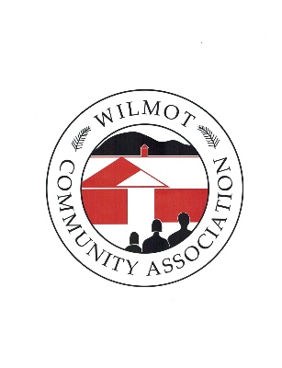

***We love it here!***

**2024 Photography Contest & 2025 Calendar**

**Sponsorship Form**

**Company name**:

**Contact name:**

**Contact email:**

**Company address:**

**Company phone:**

**Company website:**

**Preferred month(s):** 1. 2. 3.

**Please check your level of sponsorship:**

* **Banner ad** - $225

Dimensions 11-inches by 2-inches

* **Business card ad** - $100 for each space

Dimensions 3.5-inches by 2-inches

* Please check here If you would like us to publish the same ad/s that appeared in the 2024 calendar

Complete this form and return it with your check (payable to the WCA) by Monday, August 19. Ad space and preferred month/s will be distributed on a first-come, first-serve basis.

Please send an electronic version – JPEG or TIFF format - of your ad to [wca@wilmotwca.org](mailto:WCA@WilmotWCA.org). If you prefer to have the WCA design your ad, please email an electronic copy of your logo along with your request.

Use the enclosed envelope to mail your payment and sponsorship information to:

WCA Photography Contest & Calendar

Wilmot Community Association

PO Box 23

Wilmot, NH 03287

Thank you again for your support! If you have any questions, please contact the WCA by email at

[wca@wilmotwca.org](mailto:wca@WilmotWCA.org).